Name:Syed Muhammmad Sovaid Shah

Roll No :BSEF17A525

OS LAB 01

BASIC SHELL COMMANDS

Task 1

With help of whoami

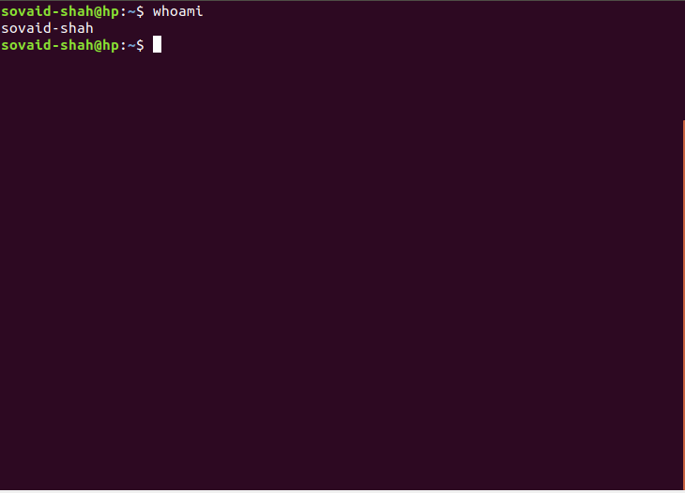

Task 2:

Using touch Filename

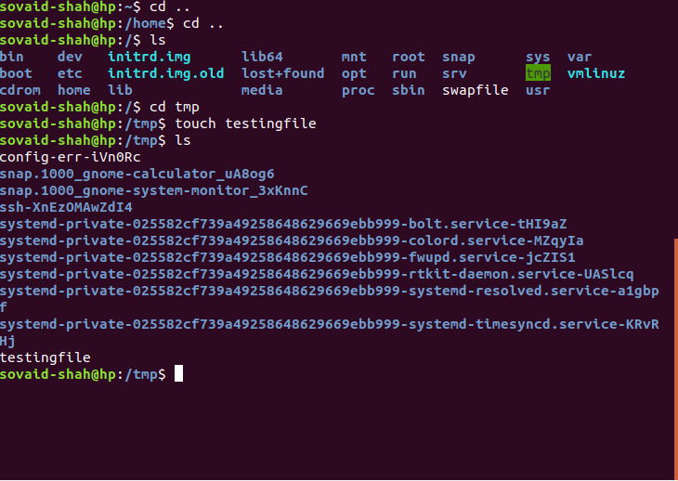

Task 3

Using ls -l to check info on file



Task 4

Rm to delete a file while rm -r to delete a occupied directory and rmdir to delete an empty directory

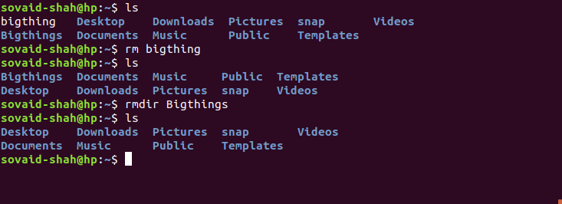

Task 5

cd /home to go directly to home directory

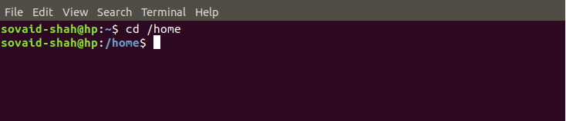

Task 6

Mv to rename a file from tryit& to tryit_now

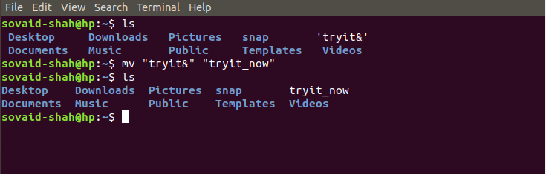

Task 7

Alias myclear=clear to give another name to clear command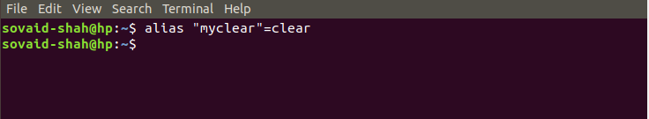

Task 8(a)

Output will be showing of directories present in the home

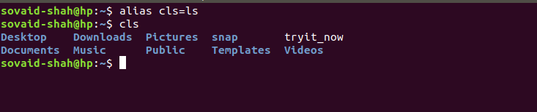

Task 8(b)

Output will be that we can’t create directories with same name

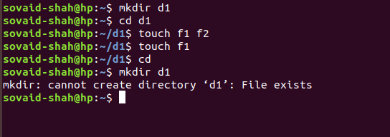

QUESTIONS(2)

Task 1

Mkdir /tmp/BSEF17A525 /tmp/BSEF17A525/SovaidShah /tmp/BSEF17A525/SovaidShah/OS to make three directories and sub directories

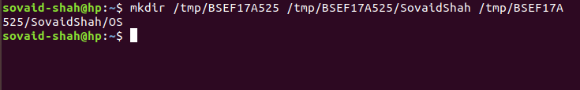

Task 2

Ls -ad .* -l to display hidden files

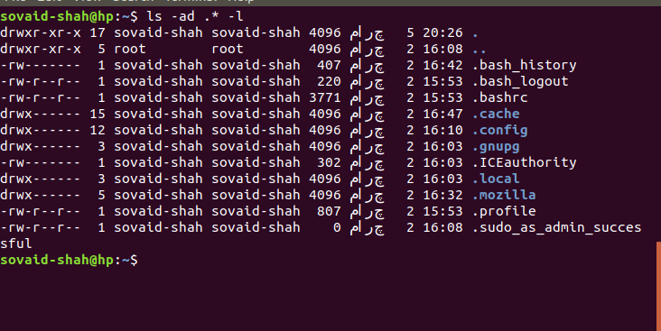

Task 3

Rm -r/tmp/BSEF17A525 to delete directories and their respective sub directories and rmdir /tmp/BSEF17A525/SovaidShah/OS /tmp/BSEF17A525/SovaidShah /tmp/BSEF17A525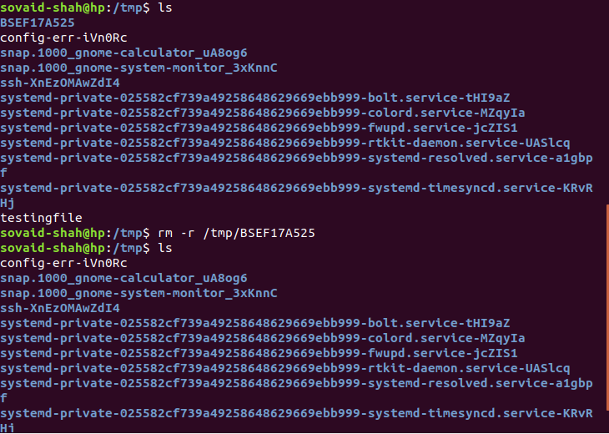

Task 4

Cat > testFile to write files and Ctrl+Z to end writing then cat -n testFile to check no of lines with text

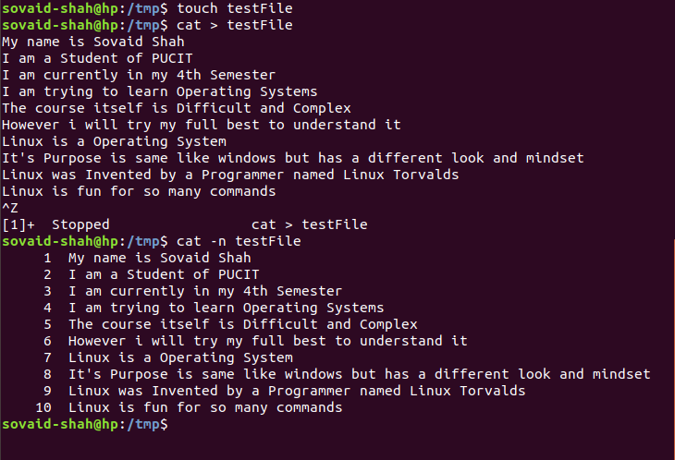

Task 5

Mv testFile test@File to rename and no it doesn’t exist anymore

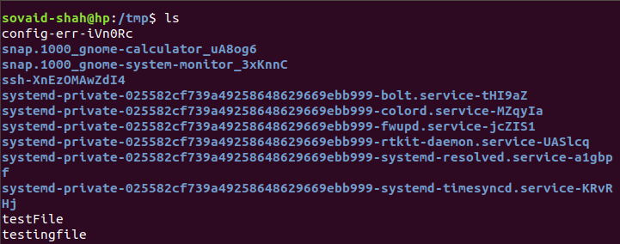

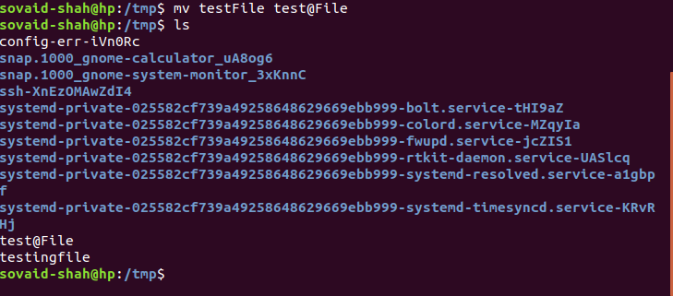

Task 6

Tail -2 testFile to display last 2 lines of file

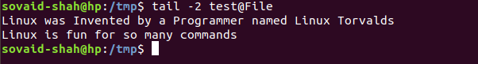

Task 7

Alias unleash =ls -ad .* -l to make unleash a command to display hidden files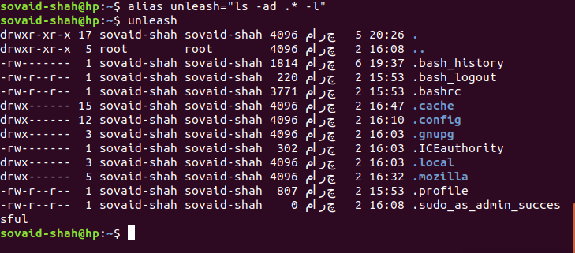

Task 8

Use man “command name” e.g

man sudo .Can’t display all of it as it shows much amount of manual



Task 9

Type type shows it’s a builtin so it is a internal Command

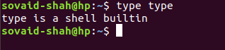

Task 10

Rm -r directory name to remove directory

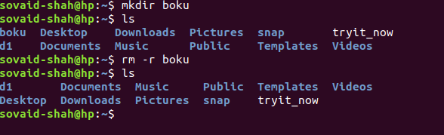

QUESTIONS

Absolute Path

Task 1

Mkdir/home/dilwaer/reports to make directory in dilwaer(pwd home)

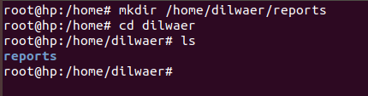

Task 2

Mkdir/home/abdul to make abdul in home(pwd reports)

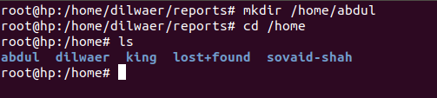

Task 3

Touch ../../abdul/dile1 to make file1 in abdul(pwd reports)



Task 4

Mkdir../staff/arif ../staff/rauf to make arif and rauf directories in staff(pwd abdul)

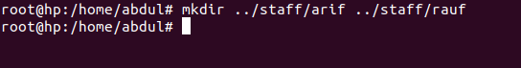

Task 5

Touch arif/file2 rauf/file3 to make file2 and file3 in arif and rauf (pwd staff)



Task 6

Cp function used to copy file2 and file 3 to abdul directory(pwd staff)



Task 7

Cp -r../staff/ ../dilwaer/newdir/ to copy staff directory with it’s subdirectories to newdir directory(pwd abdul)



Task 8

Rm -r../../staff to remove staff with its subdirectories(pwd newdir)



Task 9

Mv command to rename file2 to refile2

